Notice of Regular Meeting Board of Trustees
Charlotte Independent School District
41 Rose Blvd., Bldg. O (Old Cafeteria) Charlotte, TX 78011
February 21, 2024

Regular Board Meeting for February 21, 2024 has been cancelled.

This notice was posted in compliance with the Texas Open Meeting Act on Friday February 16, 2024, at 2:00 p.m.

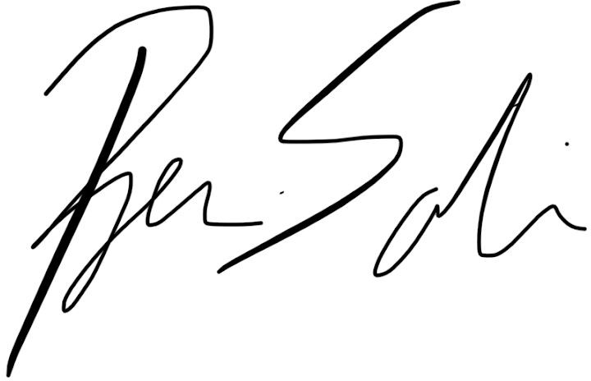
For the Board of Trustees

